USN | 1 | M | S
M S RAMAIAH INSTITUTE OF TECHNOLOGY
(AUTONOMOUS INSTITUTE, AFFILIATED TO VTU)
BANGALORE – 560 054
SEMESTER END EXAMINATIONS – MAY/JUNE 2016
Course & Branch | : | B.E. – Computer Science and  Engg./Information Science  and Engg. | Semester | : | IV
Subject | : | Engineering Mathematics-IV | Max. Marks | : | 100
Subject Code | : | CS/ISMAT401 | Duration | : | 3 Hrs

Instructions to the Candidates:
- Answer one full question from each unit.
- Use of Statistical table is permitted.

 |  | UNIT – I
1. | a) | Define Interpolation. | CO1 | (02)
 | b) | Use Simpson’s 1/3 rule to evaluate:  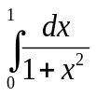considering 5 equidistant ordinates. | CO1 | (03)
 | c) | The following table gives the population of a city during the last six censuses. Estimate the increase in the population during the period from 1985 to 1988. | CO1 | (08)
  Years: x | 1941 | 1951 | 1961 | 1971 | 1981 | 1991
  Population (in lakhs): y | 12 | 15 | 20 | 27 | 39 | 52
 | d) | Solve the equation:  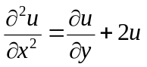 by method of separation of variables. | CO1 | (07)
2. | a) | Define partial differential equation and write one example. | CO1 | (02)
 | b) | Solve the PDE :  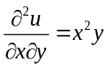 by Direct Integration method. | CO1 | (03)
 | c) | Use an appropriate interpolation formula to find the radius of curvature at x= 3.0 form the following data. | CO1 | (08)
  x | 3 | 5 | 7 | 9 | 11
  y | 28.27 | 78.54 | 153.93 | 254.47 | 380.13
 | d) | The following gives the viscosity of an oil as a function of temperature. Use Lagrange’s formula to find the viscosity of oil at a temperature of 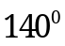 | CO1 | (07)
  Temp⁰ | 110 | 130 | 160 | 190
  Viscosity | 10.8 | 8.1 | 5.5 | 4.8
 |  | UNIT – II
3. | a) | A random variable 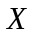 is uniformly distributed over the interval (-2,2). Find : 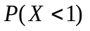 | CO2 | (02)
 | b) | A car hire firm has two cars which it hires out day by day. The number of demands for a car on each day is distributed as a Poisson distribution with mean 1.5. Calculate the proportion of days (i) on which there is no demand. (ii) on which demand is refused. | CO2 | (03)
 | c) | A random variable X has the following probability function  Find: (i) k ; (ii) P(|2 X-1|>5) and (iii) P(|3X-2|<2) | CO2 | (08)
  X | -5 | -2 | 0 | 2 | 4 | 8 | 10
  P(X) | k | 2k | 2k | 3k | k² | 2k² | 7k²+k
 | d) | When the mean of marks was 50% and S.D. 5% then 60% of the students failed in an examination. Determine the ‘grace’ marks to be awarded in order to show that 70% of the students passed. Assume that the marks are normally distributed. | CO2 | (07)
4. | a) | Write the mean and variance of a uniform distribution. | CO2 | (02)
 | b) | The length of telephone conversation in a booth has been an exponential distribution and found on average to be 5 minutes. Find the probability that a random call made from this booth ends less than 5 minutes. | CO2 | (03)
 | c) | In a bombing action there is a 50% chance that any bomb will strike the target. Two direct hits are needed to destroy the target completely. How many bombs are required to be dropped to give a 99% chance or better of completely destroying the target. | CO2 | (08)
 | d) | The pdf of a random variable X is given by  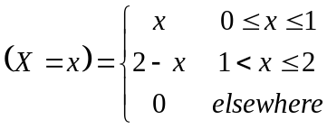  Find:  - Cumulative distribution function F(X) and  - P(X ≥ 1.5). | CO2 | (07)
 |  | UNIT – III
5. | a) | Define Ergodicity. | CO3 | (02)
 | b) | Classify the stochastic process. | CO3 | (03)
 | c) | A bag contains 3 white,2 red,2 green bulbs. 3 bulbs are selected at random. if x & y are DRV denoting number of white and red bulbs respectively, Determine:  - joint distribution of X and Y  - Marginal distribution of X &Y  - Cov(X,Y). | CO3 | (08)
 | d) | Consider a stochastic process defines on a finite sample space with three sample points. Its description is provided by the specifications of the three sample functions. 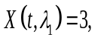 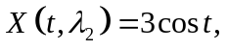 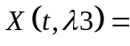 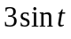. Also given the probability of the assignment P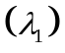= P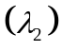 = P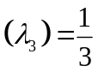 , compute μ(t) and R(t₁, t₂). Decide whether the process is SSS or WSS. | CO3 | (07)
6. | a) | Define Auto correlation. | CO3 | (02)
 | b) | The joint probability density function of X and Y is given by  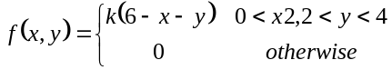 Find the value of k. | CO3 | (03)
 | c) | Suppose that the joint density function of two continuous random variables X and Y is 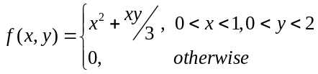  Find: (i) 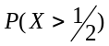 (ii) 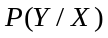 | CO3 | (08)
 | d) | A stochastic process with its ensemble functions are assumed to have equal probabilities are given by: 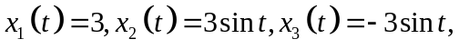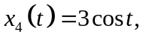 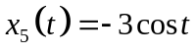, 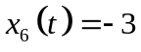. Show that the process is WSS but not SSS. | CO3 | (07)
 |  | UNIT – IV
7. | a) | Define stochastic matrix. | CO4 | (02)
 | b) | Find the fixed probability vector of the matrix  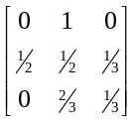 | CO4 | (03)
 | c) | At a one man barber shop, it takes on the average half an hour for a hair cut and customers arrive at an average rate of one per every 45 minutes, If the Poisson Exponential model is assumed, at any point in time, on the average  - How many customers will there be in the shop?  - What time will a customer spend in the shop?  - Of this time, what part be spent waiting to be served?  - What portion of the day will barber be idle? | CO4 | (08)
 | d) | A salesman’s territory consists of three cities A, B & C. He never sells in the same city on successive days. If he sells in city A, then the next day he sells in city B. However, if he sells in either B or C, then the next day he is twice as likely to sell in city A as in other city. In the long run how often does he sell in each of the cities? | CO4 | (07)
8. | a) | Define Probability vector. | CO4 | (02)
 | b) | Classify stochastic process. | CO4 | (03)
 | c) | Two boys b₁ and b₂ and two girls g₁ and g₂ are throwing a ball from one to the other. Each boy throws the ball to the other with probability ½ and to each girl with probability ¼. On the other hand, each girl throws the ball to each boy with probability ½ and never to the girl. In the long run, how often does each receive the ball? | CO4 | (08)
 | d) | Arrivals at a telephone booth are considered to be Poisson with an average time of 10 minutes between one arrival and the next. The length of a phone call is assumed to be distributed exponential with 3 minutes. What is the probability that a person arriving at the booth will have to wait? | CO4 | (07)
 |  | UNIT – V
9. | a) | Define Type-I and Type – II errors. | CO5 | (02)
 | b) | The nine items of a sample have the following values: 45, 47, 50, 52, 48, 47, 49, 53, 51. Does the mean of these differ significantly from the assumed mean of 47.5? | CO5 | (03)
 | c) | The following data relate to the marks obtained by 11 students in 2 tests, one held at the beginning of a year and the other at the end of the year after intensive coaching.  Do the data indicate that the students have benifited by coaching? | CO5 | (08)
  Test 1 | 19 | 23 | 16 | 24 | 17 | 18 | 20 | 18 | 21 | 19 | 20
  Test 2 | 17 | 24 | 20 | 24 | 20 | 22 | 20 | 20 | 18 | 22 | 19
 | d) | Two samples of sizes 9 and 8 gave the sums of squares of deviations from their respective means equal to 160 and 91 respectively. Can they be regarded as drawn from the same normal population. | CO5 | (07)
10. | a) | Define sampling distribution of means. | CO5 | (02)
 | b) | A certain stimulus administered to each of the 12 patients resulted in the following change in blood pressure. 5, 2, 8, -1, 3, 0, 6, -2, 1, 5, 0, 4. Can it be concluded that the stimulus will increase the blood pressure? | CO5 | (03)
 | c) | The mean lifetime of a sample of 25 bulbs is found as 1550 hrs with a SD of 120h. The company manufacturing the bulbs claims that the average life of their bulbs is 1600h. Is the claim acceptable at 5% LOS? | CO5 | (08)
 | d) | Fit a Poisson distribution for the following data and test the goodness of fit. | CO5 | (07)
  x: | 0 | 1 | 2 | 3 | 4 | 5 | 6 | Total
  f: | 273 | 70 | 30 | 7 | 7 | 2 | 1 | 390
**********************

